

<项目名称>
概念设计说明书

微软(中国)有限公司顾问咨询部

2026年11月
目 录
第1章 概述 3
1.1 文档目的 3
1.2 参考资料 3
第2章 功能需求 4
2.1 操作者 4
2.2 业务规则 9
2.3 业务需求 16
第3章 用例和使用场景 21
3.1 系统用例图 21
3.2 订单管理 22
3.2.1 UC05订单管理用例图 22
3.2.2 UC05订单管理流程图 23
3.2.3 UC05.1订阅产品规格说明书使用场景 23
3.3 业务数据 25
第4章 客户和用户信息 26
4.1 期望值 26
4.2 项目目标和优先级 26
4.3 分析需求和功能 26
4.4 限制条件 26
第5章 IT环境 28
5.1 标准与规范 28
5.2 公共技术与组件 28
5.3 硬件与网络环境 28
5.4 外部系统 28
5.4.1 系统描述 28
5.4.2 接口描述 28
第6章 非功能需求 29
6.1 业务 29
6.1.1 可用性/可靠性 29
6.1.2 系统容量/可扩展性 29
6.1.3 安全性 29
6.1.4 性能 29
6.2 用户 29
6.2.1 用户体验 29
6.2.2 可用性/易用性 29
6.2.3 可访问性 30
6.2.4 用户培训 30
6.3 系统 30
6.3.1 系统/服务的依赖关系 30
6.3.2 与外部系统的互操作性 30
6.3.3 对网络资源的评估 30
6.4 运行维护 30
6.4.1 可管理性 30
6.4.2 可支持性 31
6.4.3 可用性/可靠性/安全性 31
6.4.4 运维人员与培训 31
6.4.5 系统迁移 31
6.4.6 服务等级要求/7x24要求 31

- 概述
  - 文档目的
《概念设计说明书》是外部文档，是产品经理和项目经理从业务和用户角度收集业务信息、当前的应用环境等信息，并从利用这些信息获取、分析业务和用户的需求，验证和优化解决方案。在《概念设计说明书》中要包含系统当前和未来使用场景的描述，目标是使用户和项目组在系统完成后所具有的功能和使用方式上达成共识。
  - 参考资料
说明编写《概念设计书》中参考的资料。例如《业务调查表》，也可以有国家的行业标准、客户提供的运营规范、其它业务参考书籍等。

- 功能需求
  - 操作者
操作者 | 描述 | 来源 | 业务职称
The person, organization, or external system that plays a role in one or more interactions with the system. | Describes the role and the duties that are performed by the role when it interacts with the system. | Provides traceability between this record and the source of the information. Can include such details as location and the date and time when information was gathered. | List all the real-world entities that correspond to the role identified in the first column.
Consumer | Browses and orders products online, views and prints specifications, and tracks orders. This actor buys products for personal use. | Ann Beebe | Web customer, sales representative, sales manager, reseller, customer, consumer.
Customer | Can refer to a Consumer, Client, or Reseller. | Kim Akers | Web customer, reseller, consumer, customer, contract client.
Client | Can refer to a Consumer, Client, or Reseller. Additional information that was gathered in subsequent meetings with Adventure Works Cycles employees indicate that client really refers to contract Clients and Resellers. | Kim Akers | Reseller, contract client.
Web Customer | Refers to a Consumer. | Kim Akers | Web customer, sales representative, sales manager, reseller, customer.
Contact | Customer information that is saved so that the Sales Staff can communicate with this contact in the future. | Nancy Anderson | Web customer, reseller, contract client, another employee within Adventure Works Cycles, vendor, potential customer, or any other business entity that is interested in Adventure Works Cycles or that Adventure Works Cycles is interested in.
Visitors | Web site visitors. Although this might be another term for Web Customer, not every person who visits the Web site will be a Customer. | Susan Metters | Web customer, sales representative, sales manager, reseller, contract client, potential customer, or any person that is visiting the Web site.
Reseller | Buys products in bulk for resale. Browses and orders bulk products. Views and prints specifications, and tracks orders. | Nancy Anderson | Contract client, customer.
Buyers | Refers to a Reseller. | Kim Akers | Reseller, contract client.
Employees | The people who work for Adventure Works Cycles and Wide World Importers. | Nancy Anderson | Sales manager, sales representative, production clerk, and any other individual that is employed by Adventure Works Cycles or Wide World Importers.
Sales Associate | Refers to a Sales Representative. | Kim Akers | Sales representative, sales manager.
Sales Representative | Downloads and uploads reseller and order information, which affects accounting, inventory, and product data. Views reseller and product data as described in metrics. | Nancy Anderson | Sales representative.
Salesperson | Refers to a Sales Representative. | Kim Akers | Sales representative, sales manager.
Sales Manager | Downloads and uploads customer and order information, which affects accounting, inventory, and product data. Views customer and product data as described in metrics. Creates management reports, establishes sales quotas, creates regional reports, and makes adjustments. | Nancy Anderson | Sales manager.
Territory Sales Manager | Refers to a Sales Manager. | Karan Khanna | Sales manager.
Sales Force | Refers to Sales Staff. | Nancy Anderson | Sales representative, sales manager, regional office administrator.
Sales Staff | This is the combination of Sales Representatives, Sales Managers, Regional Office Administrators, and others. It is the team of Adventure Works Cycles sales professionals that conduct functions related to the sales of Adventure Works Cycles products. | Laura Steele | Sales representative, sales manager, regional office administrator.
Sales Team | Refers to Sales Staff. | Laura Steele | Sales representative, sales manager, regional office administrator.
Sales Organization | Refers to Sales Staff. | Nancy Anderson | Sales representative, sales manager, regional office administrator.
Product Clerk | Browses and orders products online, views and prints specifications, tracks orders, adjusts product catalog data, and views and prints inventory reports. | Luis Bonifaz | Production clerk.
Production Clerk | Refers to Product Clerk. This can be used interchangeably with Product Clerk because of a recent title change within the Adventure Works Cycles organization. | Susan Metters | Product clerk.
Data Entry Operator | Refers to Product Clerk. | Susan Metters | Product clerk, production clerk.
Department Administrator | Refers to Regional Office Administrator. | Laura Steele | Regional office administrator, department administrator, administrative assistant.
Regional Office Administrator | Browses, enters, and reviews departmental information online for departments listed in metrics. | Nancy Anderson | Department assistance, administrative assistant, office manager.
IT Professional | Refers to Operations. | Fernando Caro | Operations manager, computer operator, network administrator, database administrator, applications programmer, software design engineer, technology consultant.
Staff | Sales and marketing. | Brannon Jones | Sales representative, sales manager, regional office administrator, marketing manager, product manager.
Accounting | Accesses customer and order information to create invoices for orders that a Customer has placed. Manages the revenue generated by the company and the expense the company incurs. | Karan Khanna | Accounting manager, accountant, accounting assistant.
Accounts Receivable | Refers to a portion of Accounting that manages the revenue of the company. | Karan Khanna | Accounting manager, accountant, accounting assistant.
Accounts Payable | Refers to a portion of Accounting that manages the expenses for the company. | Karan Khanna | Accounting manager, accountant, accounting assistant.
Marketing | The Marketing department is responsible for advertising and generating interest in the products that Adventure Works Cycles manufactures. | Laura Steele | Marketing manager, product manager.
Operations | Responsible for maintaining the system, ensuring that the data is always current and safe, and troubleshooting problems and errors that occur within the system. | Mike Danseglio | Operations manager, computer operator, network administrator, database administrator.
Executive | Uses the system to create reports related to current sales, and forecasts for future sales and revenue. | Susan Metters | CEO, CFO, CIO, vice president, director.
Order Fulfillment | Once an order has been submitted, this group processes and ships the order. Receives submitted order reports each morning. | Karan Khanna | Inventory manager, order processor, mail clerk.
Engineering Group | Designs new products, updates the designs of existing products, produces detailed specifications for each product, reviews any requested changes to products. | Luis Bonifaz | Senior engineer, engineer.
Product Engineering | Refers to the Engineering Group. | Luis Bonifaz | Senior engineer, engineer.
Wide World Importers | Company purchased by Adventure Works Cycles. Manufactures parts for bicycles that are built by Adventure Works Cycles. | Susan Metters | Wide World Importers.
Purchasing | Performs the business function of buying materials needed to manufacture Adventure Works Cycles products. | Bradley Beck | Purchasing manager, account representative.
Vendor | Supplies Adventure Works Cycles with materials for the manufacturing process. | Bradley Beck | Vendor.
Vice President of Sales and Marketing | Oversees the sales and marketing business for Adventure Works Cycles. Reviews customer, sales, and marketing information and forecasts sales goals. | Jenny Gottfried | Vice president of sales and marketing.

  - 业务规则
业务规则可以在用例和使用场景中进行描述，也可以在本节单独描述。
ID | 业务规则名称 | 描述 | 负责人/部门 | 用例编号 | 当前流程
1 | Timely Product Information Adjustments | The product information in the online catalog must be current 100% of the time. Adjustments to this information must be made at any time. | Brannon Jones, Production Clerk. Interview dated October 6, 2002 | UC 06.1.1  UC 06.3.1 | 1. Product is identified by Marketing and/or Engineering.  2. Current information is reviewed and modifications are identified.  3. Technical details are reviewed by Engineering. Marketing details are reviewed by Marketing. This review is conducted in a face-to-face meeting with Engineering, Marketing, and Production Clerk.  4. Production Clerk notes changes to information and obtains approval from Engineering and Marketing to make the changes.  5. Production Clerk makes the changes to the product information.  6. Production Clerk notifies product information "owners" in Engineering and Marketing to review the changes.  7. After approval is given by all owners, Production Clerk saves the changes.
2 | Quarterly Sales Cycle Maps to Major Catalog Changes | Although prices may vary daily, they are kept relatively stable for customers who are making regular purchases, therefore a major pricing update, incorporating any special offers, is limited to once a quarter. | Brannon Jones, Production Clerk. Interview dated October 6, 2002 | UC 06.1.1  UC 06.3.1 | 1. Current pricing information is reviewed and modifications are identified by Marketing.  2. Special Offers and Promotions are defined by Marketing.  3. Production Clerk notes changes to information and obtains approval from Marketing to make the changes.  4. Production Clerk makes the changes to the product information and updates special offers and promotional material.  5. Production Clerk notifies information "owners" in Marketing to review the changes.  6. After approval is given by owners, Production Clerk saves the changes.
3 | Reactivating Deleted Products | A product can be "deleted," meaning that it is no longer sold by Adventure Works Cycles. However, the product information should be available in case the product is reactivated at a future time. | Brannon Jones, Production Clerk. Interview dated October 6, 2002 | UC 06.1.1  UC 06.4 | 1. Product is identified by Marketing and/or Engineering.  2. Production Clerk is notified that the product should be removed from the catalog. Notification comes from Marketing (Engineering does not have the authority to reactivate a product without marketing approval).  3. Production Clerk archives product information and saves the information in text and graphics files on an internal business server.  4. If a product is reactivated, the Production Clerk receives notification from Marketing (Engineering does not have the authority to reactivate a product without Marketing approval).  5. Production Clerk creates a new product record in the database and copies the information from the files on the internal business server to the database record.  6. Production Clerk notifies product information "owners" in Engineering and Marketing to review the new product record.  7. After approval is given by all owners, Production Clerk makes the product record available to the catalog.
4 | Authorization for Catalog Changes | No change to product information can be made publicly available without the approval from the information "owners," usually Engineering and/or Marketing. | Brannon Jones, Production Clerk. Interview dated October 6, 2002 | UC 06.1.1  UC 06.3.1  UC 06.4 | Derived from BR1, BR2
5 | Delivery of Daily Pricing Updates to Sales | The Sales force needs to use the most up-to-date information about product pricing and related information, such as availability. Otherwise, sales representatives miss receiving changes that do affect them. This results in sales representatives having to redo orders and recalculate pricing. | Nancy Anderson, Territory Sales Manager.  Interview dated October 11, 2002 | UC 06.3.1 | Every morning of every day:  1. The sales representative connects to the corporate network.  2. The sales representative downloads the new pricing list.  Note: The download process does not identify which prices have been modified for that individual sales representative.
6 | Sales Opportunities are Tracked Using Opportunity Rules | Opportunity rules help a sales representative convert an opportunity into a closed sale. For example, a rule might be: Customer C will buy product P if (a) the price of product P is reduced by 5 percent or (b) product P comes with components X, Y, and Z as options. | Nancy Anderson, Territory Sales Manager.  Interview dated October 11, 2002 | UC 04.5  UC 04.6.2 | 1. A sales representative creates a Microsoft Word document and stores information such as contact name, address, phone number, which products the contact is interested in, date first contact was made, date last contact was made, and so on.  2. In the same Word document, the sales representative enters "opportunity rules."  3. The sales representative then tracks the success of the rules in future sales dealings with the customer.
7 | Application of Discounts | A sales representative can offer up to a 15% discount, and up to 20% with the authorization of the sales manager. | Nancy Anderson, Territory Sales Manager.  Interview dated October 11, 2002 | UC 05.5.1  UC 05.5.1.1  UC 05.5.2 | 1. The sales representative negotiates a discount with the customer.  2. If the discount is <= 15%, the sales representative can apply it directly to the customer's order.  3. If the discount is 15% to 20%, the sales representative e-mails the sales manager to request the discount.  4. The sales manager either approves the discount, suggests a lower discount, rejects the application, or applies the discount directly to the customer's order for the sales representative.  5. The sales manager e-mails the sales representative with the decision.  6. The sales representative then informs the customer of the discount.
8 | Check Delivery on Receipt | A customer uses an order to check the content of a given delivery. | Karen Friske, Web Customer.  Interview dated October 6 2002 | UC 05.2  UC 05.9 | 1. After creating an order, the customer prints and files a copy of the order summary.  2. Prior to the order delivery, the customer uses the order to generate a list of asset numbers for the goods.  3. After receiving the order, the customer takes the copy of the order from the file and uses it as a checklist for the received goods, as well as for the assignment of the asset numbers.
9 | Authorization for Information Access | Certain roles have access to certain information types and functions. Current roles include Sales Representative, Sales Manager, Customer, Reseller, Product Clerk, Human Resources. For example, forthcoming campaigns may be visible to resellers, but not to more general Web customers/consumers. | Marc Zimmerman, Information Services Manager.  Interview dated October 11, 2002 | Applies to all role based UC's (e.g. UC 05.5, 04.5) | 1. A suitable authority is requested for creation of a role. For example, resellers can be created by the sales manager; sales managers by HR; customers by themselves.  2. The role is created and authorized by the authorization authority.
10 | Payment on Account | Resellers may have accounts with 30-day invoicing terms | Nancy Anderson, Territory Sales Manager.  Interview dated October 11, 2002 | UC 05.9 | 1. When the sales manager authorizes the creation of a reseller, the manager also specifies whether the reseller can make payments on account, or needs to pay directly (using a bank transfer, check or a credit/debit card).  2. This information is taken into acount at the point of sale when the reseller places an order.  3. Available payment mechanisms can be changed at any time by the sales manager.
11 | Payment by Credit Card | Most customers make direct purchases from Adventure Works Cycles using a credit or debit card. Payment is received prior to delivery of the order. | Michael Patten, Sales Representative.  Status meeting dated October 14, 2002 | UC 05.1  UC 05.2  UC 05.3  UC 05.4  UC 05.5  UC 05.9 | 1. The customer places an order, either on the telephone or on the Web.  2. The customer is requested for payment details, such as a credit or debit card.  3. The credit/debit card details are used to make the payment.  4. The order is accepted and delivery is initiated.
12 | Recrediting of Customer Account | If an order fails for whatever reason (for example, product no longer available, faulty product, delivery outside acceptable timescale), the customer can request a refund. In normal circumstances, this request can be authorized by a sales representative. However, if it is over a certain amount (currently $500) then it must be authorized by a sales manager. Refunds are granted only within the terms and conditions of Adventure Works Cycles, except for exceptional circumstances. | Nancy Anderson, Territory Sales Manager.  Follow-up Interview on October 12, 2002 | UC 05.3  UC 05.4 | 1. The customer requests a refund.  2. The sales representative authorizes the refund, or, if it is over $500, the sales manager authorizes the refund.  3. The refund amount is credited to the customer's bank account.
13 | Delivery Terms | Delivery terms are dependent on the customer type and/or the selected mechanism. Overnight delivery is available (at a price) to all customers as long as products are in stock. Normal delivery is within seven days of a purchase, if products are in stock. Customers can make advance orders (for example resellers at the start of a season), in which case delivery schedules are agreed upon with the sales representative. | Nancy Anderson, Territory Sales Manager.  Follow-up interview on October 12, 2002 | UC 05.1  UC 05.2  UC 05.3  UC 05.4  UC 05.9 | 1. The customer places an order, either on the telephone or on the Web.  2. The customer is asked for required delivery terms.  3. Depending on the type of order, either the customer decides the delivery terms or the terms are negotiated with a sales representative.  4. The order is delivered according to the delivery terms.  5. The customer is kept informed about the status of a delivery, for example, the date and time that the delivery is planned.
14 | Validation of a Purchase | A customer's first purchase is always checked by a sales representative, even if made on the Web. Customers who have already made a purchase that has been received can make subsequent purchases without manual intervention. The reason for this check is to prevent fraudulent purchases, in response to a past incident. | Kim Akers, Sales Representative  Interview dated October 8, 2002 | UC 03  UC 05.9 | 1. When a new customer places an order, a new account is created for the customer and the customer status is set to "new."  2. The customer places an order, either on the telephone or on the Web.  3. The order is forwarded by e-mail to the sales representative that represents the customer.  4. The sales representative checks that the order is appropriate and authorizes the order.  5. The order is processed as normal, and the customer status in their account is set to "existing."
15 | Change to Design of Product | Products go through redesign and improvements over time. Each time Engineering changes the design or the specifications of a product, it is required to go through a detailed review process. | Vice President of Engineering  Interview dated October 7, 2002 | UC 06 all | 1. Design documents are updated with proposed changes to the product.  2. The executive committee reviews the proposed design against the charter of the company as a whole.  3. The sales and marketing departments contribute customer requests, and take preliminary information back to the customers.  4. Manufacturing reviews the design to provide feedback and to prepare for the changes  5. Any feedback is incorporated into the proposed design.  6. Changes are then checked off by the proposer, and the final document is signed off by a representative of the executive committee.
16 | Phone orders can be created by Regional Office Administrators | In the absence of a sales representative or a sales manager, the regional office administrator can accept phone orders from customers. However, a sales representative or a sales manager is required to approve the order before it can be processed. | Nancy Anderson, Territory Sales Manager.  Follow-up interview on October 12, 2002 | UC 05.9 | 1. A customer calls its regional Adventure Works Cycles sales office to place an order.  2. A sales representative and the sales manager are unavailable to take the customer's order.  3. The regional office administrator takes the order.  4. The regional office administrator submits the order, but the order is routed to the appropriate sales representative and manager.  5. When the sales representative or the sales manager views the order, they review it and then either submit it to be fulfilled or contact the customer to further discuss the order.
  - 业务需求
ID | 需求描述 | 优先级 | 来源 | UC ID
1 | Manage Customers - Analyze Customers
1.1 | Must be able to analyze customer data (Currently includes by product, customer, and region. Any others?) |  | Sales Manager, sales representative
1.1.1 | Must be able to analyze profits by product |  | Sales Manager, sales representative
1.1.2 | Must be able to analyze profits by customer |  | Sales Manager, sales representative
1.1.3 | Must be able to analyze profits by region |  | Sales representative
1.2 | Must be able to sort customers (Do we need both ascending and descending sorting for these items?) |  | Sales representative
1.2.1 | Must be able to sort customers by amount of sales |  | Sales representative
1.2.2 | Must be able to sort customers by amount of sales of particular products |  | Sales Manager
1.2.3 | Must be able to sort customers by amount of sales in regions and amount of sales over a specified period of time (I assume no detail finer than the day. Check?) |  | Sales Manager, sales representative
1.2.4 | Must be able to sort customers by amount of sales over a specified period of time (I assume no detail finer than the day. Check?) |  | Sales Manager, sales representative
1.3 | Must be able to identify sales trends |  | Sales representative
1.3.1 | Must be able to identify drops in sales |  | Sales representative
1.3.2 | Must be able to identify drops in a customer's sales |  | Sales representative
2 | Manage Orders
2.1.1 | Sales representatives must be able to offer 15 percent discount in an order |  | Sales Manager
2.1.2 | Sales representatives must be able to offer discounts up to 20 percent with [sales manager's] authorization |  | Sales Manager
2.1.3 | Sales managers can offer discounts up to 20 percent |  | Sales Manager
2.1.4 | Must be able to order product specifications online |  | Sales representative, sales manager, customer
2.1.5 | Must be able to order product specifications by mail |  | Sales representative, sales manager, customer
2.2 | Customers must be able to search the sales office information by postal or ZIP code (Need this to find the closest code to where they live. Postal/ZIP will be more accurate than city, state, or country information for this purpose.) |  | Information services manager
2.3 | Must be able to create, track, revise, and cancel orders (Confirmed that requirement number 30 refers to orders.) |  | Sales representative
2.3.1 | Must be able to create an order |  | Sales manager
2.3.1.1 | Must be able to create an order with a Microsoft Windows CE-based device (Verified as the mechanism in subsequent conversations.) |  | Sales manager
2.3.2 | Must be able to track an order |  | Sales representative, information services manager
2.3.3 | Must be able to revise an order |  | Sales representative, information services manager
2.3.4 | Must be able to cancel an order |  | Sales representative
3 | Manage Products (Catalog, Categories)
3.1 | Must be able to browse products |  | Product clerk, sales representative, sales manager, customer, information services manager
3.1.1 | Must be able to browse products by category (This need confirmed in a conversation with the information services manager.) |  | Product clerk, sales representative, sales manager, customer, information services manager
3.2 | Must be able to add a new product |  | Product clerk
3.3 | Must be able to edit an existing product |  | Product clerk
3.4 | Customers must be able to search the database |  | Information services manager
3.4.1 | Customers must be able to search the database by product type |  | Information services manager
3.4.2 | Customers must be able to search the database by product |  | Information services manager
3.4.3 | Customers must be able to retrieve product description and product specifications |  | Information services manager
3.5 | The system must have the capability to provide help (Different help channels confirmed with information services manager.) |  | Information services manager
3.5.1 | The system must have the capability to provide Help by means of an IM session |  | Information services manager
3.5.2 | The system must have the capability to provide Help by means of a wizard |  | Information services manager
3.5.3 | The system must have the capability to provide Help from a FAQ file |  | Information services manager
4 | Manage Candidates and Employees
4.1 | Must be able to record information about employees and candidates |  | Human resources manager
4.1.1 | Must be able to record information about employees |  | Human resources manager
4.1.1.1 | Must be able to secure different sections of the employee review document (We will need lists describing which groups can access which data.) |  | Human resources manager
4.1.1.2 | Must be able to associate a review file with an employee rocord |  | Human resources manager
4.1.2 | Must be able to record information about candidates |  | Human resources manager
4.1.2.1 | Must be able to associate a candidate resume with candidate information in the database |  | Human resources manager
4.2 | Must be able to search for employee information |  | Human resources manager
4.2.1 | Must be able to search for documents within the employee database by keywords and by employee information |  | Human resources manager
4.3 | Must be able to track information for employees and candidates (Are the tracking needs the same for employees and candidates?) |  | Human resources manager
4.3.1 | Must be able to track information for each employee |  | Human resources manager
4.3.2 | Must be able to track information for each candidate |  | Human resources manager
4.4 | Must be able to produce reports that support planning and tracking, including planning of workforce (Further discussion needed to determine content of reports.) |  | Human resources manager
4.4.1 | Must be able to produce reports of recruiting needs by department |  | Human resources manager
4.4.2 | Must be able to produce reports of recruiting needs by job role |  | Human resources manager
4.4.3 | Must be able to produce impact analyses of changes to benefits packages |  | Human resources manager
5 | Document Management
5.1 | All users from all departments must be able to store documents in a central database |  | Information services manager
5.2 | Employees must be able to allow searches for documents |  | Information services manager
5.2.1 | Employees must be able to allow entry of different search parameters |  | Information services manager
5.3 | The system must allow an approval process for specifications (Further work needed to define the process and the roles involved.) |  | Vice president of engineering
5.3.1 | The system must allow definition of roles to take part in the specification authoring and approval process |  | Vice president of engineering
5.3.2 | The system must allow definition of routes to take part in the specification authoring and approval process |  | Vice president of engineering
5.3.3 | The system must allow definition of rules to take part in the specification authoring and approval process |  | Vice president of engineering
5.4 | Customers must be able to search the database in different languages that use different character sets |  | Information services manager
5.5 | Wide World Importers staff must have access to technical specifications |  | Information services manager
5.6 | Must be able to integrate with our MRP system |  | Information services manager
5.6.1 | Must allow Wide World Importers staff to exchange work order information and financial data |  | Information services manager
5.6.2 | Must allow vendors to deposit their product specifications directly into the database |  | Purchasing manager
5.6.2.1 | Must be able to store specifications as XML |  | Vice president of engineering
6 | Network Management
6.1 | Must be able to monitor the network centrally |  | Network administrator
6.1.1 | Must be able to monitor servers centrally |  | Network administrator
6.1.2 | Must be able to monitor application server software centrally |  | Network administrator
6.1.3 | Must be able to monitor databases centrally |  | Network administrator
7 | CEO Requirements
7.1 | to extend our product availability (Looks more like a business goal than a definable requirement.) |  | CEO
7.2 | providing a 24-hour-a-day, 7-day-a-week solution to existing customers that would like additional information about our products (Looks more like a business goal than a definable requirement.) |  | CEO
7.3 | reduce our costs by lowering our production costs (Looks more like a business goal than a definable requirement.) |  | CEO
7.4 | need to address our own manufacturing and production costs (Looks more like a business goal than a definable requirement.) |  | CEO

- 用例和使用场景
使用用例图和当前使用场景、未来使用场景从用户角度描述解决方案的功能及如何被使用。用例图和使用场景的目标是根据需求，设计系统的功能和使用方式，使用户和项目组在系统功能和用法上达成共识。
  - 系统用例图
系统用例图是系统总体使用方式的概要用例图，是所有用例图的基础。
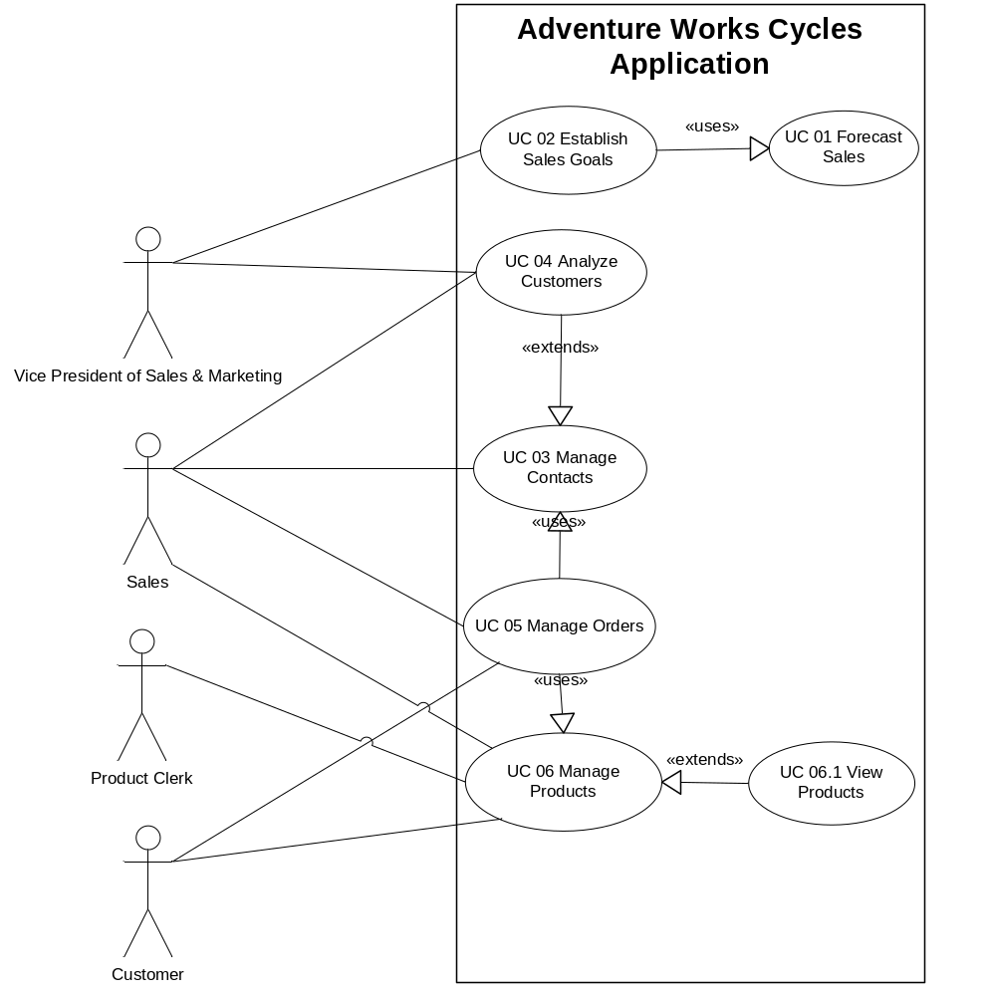

  - 订单管理

UC05订单管理用例图
下图为订单管理的示例用例图
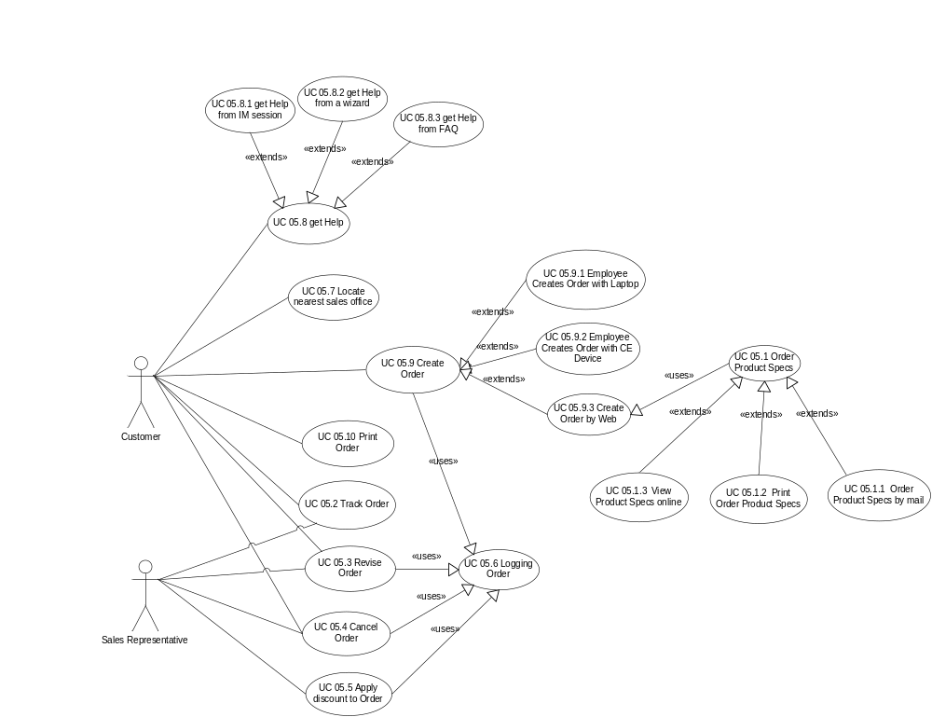
用例描述了系统中实现一个目标所涉及到的操作者、对象和行为，用例标识了：
- 系统边界
- 任务顺序和层次
示例
- 客户创建订单
- 销售代表跟踪订单
每个任务都需要定义：
- 谁来完成行为—操作者
- 行为
- 行为的对象
操作者 | 行为 | 对象
客户 | 创建 | 订单
销售代表 | 跟踪 | 订单

UC05订单管理流程图
业务执行的流程。主要是完成一个完整业务所涉及的各个阶段以及这些阶段之间可能有的流转关系。对每个相关业务都需要单独描述。描述的方式可以采用Visio 中的“基本流程图”和“工作流程图”模板，通过图形的方式描述一个业务的工作流程。例如：
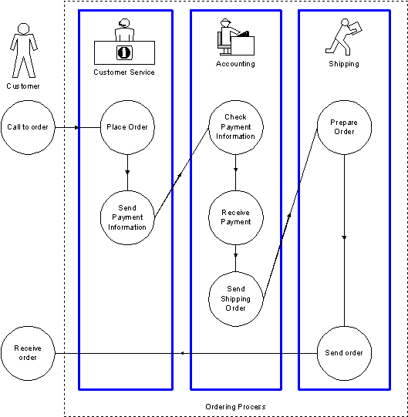

UC05.1订阅产品规格说明书使用场景
使用场景更详细地描述了用例的细节，一个用例常常需要几个场景来描述。使用场景还用于描述异常情况的处理方法。创建使用场景的方法如下：
- 确定前提条件
  - 在场景发生前需要怎样的信息和条件?
- 定义事后状况
  - 任务序列完成了怎样的工作或目标?
- 将活动拆分为离散的步骤
- 定义异常
  - 可能需要为异常设定使用场景
- 定义使用场景与需求的对应关系
- 定义使用场景来源
示例：
- 用例ID: UC 05.1 订阅产品规格说明书
标题: UC 05.1订阅产品规格说明书
简称: 订阅产品规格说明书
需求ID: 14.1
- 目的
Enable a customer to order product specifications without speaking to an employee.
- 场景描述
When a customer is viewing an item in the catalog, the customer can receive the product specification by requesting it and specifying the delivery mechanism. The product specification is then delivered according to the selected mechanism. Valid delivery mechanisms are identified in use case 05.1.1, use case 05.1.2, and use case 05.1.3.
- 前提条件与假设
- The customer has browsed to the Adventure Works Cycles Web site, and the home page has successfully appeared in the user’s browser.
- The customer is browsing the product catalog.
- The customer has already selected a product from the catalog on the Adventure Works Cycles Web site.
- 操作者
- Customer
- 基本过程
- Use case begins when customer decides to order product specification.
- Customer orders product specification.
- System prompts for dispatch mechanism.
- Customer selects dispatch mechanism.
- System prompts for delivery information.
- Customer enters delivery information.
- System validates delivery information and attempts to fulfill order.
- Use case ends when system has accepted order request.
- 替代过程
- If no product specifications are available for a product, this use case should be rendered inaccessible. For example, remove the link on the Web page, or return a message indicating that no specifications are available.
- 使用或派生的用例
- Not applicable
- 用户执行要求
- None
- 频率
Infrequent
- 业务规则
描述本场景需要遵循的业务规则，也可以用单独的章节描述业务规则，在此说明使用的规则ID。

业务数据
说明用例中操作和产生的业务数据，以及这些业务数据的属性。业务数据是数据库逻辑设计的基础。

客户和用户信息
从客户/用户面谈记录（参见概念设计附录）中整理每一次面谈的数据，形成客户/用户信息。给每一类用户创建一个用户信息。
客户是指付钱作项目的人。对于内部开发项目，客户可能是某个部门。
用户是指真正使用软件的人。用户信息是项目组首先了解信息之一。
包括所有可能的用户是很重要的，例如，经理可能需要收到打印好的报告，而IT支持人员需要维护软件。
需要注意的是：业务目标应当体现客户的期望和需求，用户信息应当体现用户的期望、需求和目标。

期望值
表示应用解决方案后客户或用户期望获得的利益，例如：
- 降低成本
- 提高性能
- 客户满意度
理解客户和用户期望值是保证方案能够满足客户和用户要求的先决条件。

项目目标和优先级
从客户/用户角度简要陈述项目目标和相对优先级。这些目标和陈述可用于制订时间表，并且在项目过程中平衡进度、资源和功能的相互管理。

分析需求和功能
客户或用户真正想要的是什么。

限制条件
例如：
- 时间
- 费用
- 网络带宽
- 用户使用习惯
- 外部系统
- IT环境

标准与规范
列举对本项目具有指导意义的IT总体规划以及相关标准与规范。

公共技术与组件
如：EIP / EAI / 数据交换 / 安全认证等

硬件与网络环境
说明用户方信息系统建设状况，如网络拓扑结构，通讯线路设置等。这提供了产品设计、部署的基本信息。

外部系统
    - 系统描述
描述外部系统的作用及与本项目的关系。
    - 接口描述
描述外部系统的接口形式，如：数据库 / API / 文件 / 认证 / 数据交换的频率等。
描述使用何种方式与本项目对接。
- 非功能需求

业务

可用性/可靠性
<<Begin text here>>

系统容量/可扩展性
<<Begin text here>>

安全性
<<Begin text here>>

性能
<<Begin text here>>

用户

用户体验
<<Begin text here>>

可用性/易用性
<<Begin text here>>

可访问性
<<Begin text here>>

用户培训
<<Begin text here>>

系统

系统/服务的依赖关系
<<Begin text here>>

与外部系统的互操作性
<<Begin text here>>

对网络资源的评估
<<Begin text here>>

运行维护
<<Begin text here>>

可管理性
<<Begin text here>>

可支持性
<<Begin text here>>

可用性/可靠性/安全性
<<Begin text here>>

运维人员与培训
<<Begin text here>>

系统迁移
<<Begin text here>>

服务等级要求/7x24要求
<<Begin text here>>

